Game Information

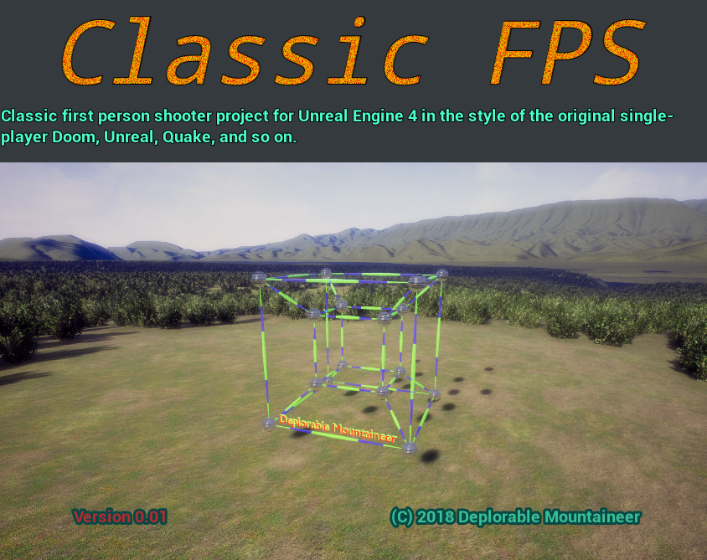
Unique Project ID: {AED64A86-47D8-D36A-F0A9-2093602951A6}
Name: Classic FPS Version 0.01
Description: Classic first person shooter project for Unreal Engine 4 in the style of the original single-player Doom, Unreal, Quake, and so on.
Company: Deplorable Mountaineer
Website: https://deplorablemountain.wixsite.com/games
Copyright: © 2018 Deplorable Mountaineer
Contact: Deplorable.Mountaineer@gmail.com
Palette Colors: #38c098, #F8BE00, #B52930, #10655E, #ffffff, #42484f, #1EF858, #F89245, #A057F8, #45F8B5, #613F29


Palette Gradient:


